Practical
GUI Construction

Exercise 1 Digital Stopwatch

- Go to the website for the module and download the code for the digital stopwatch application described in the lecture. Check that you can compile and run this code.

- Modify the code so that the stopwatch has a pause button, as in Figure 1. The pause button should behave in the same way as the stop button except that the clock is not reset to zero after a pause. In other words if you pressed start, let the stopwatch run for five seconds, and then pressed Pause, the watch would read ‘00.00.05.00’ (as it would do if you had pressed start). However if you leave it paused for say 2 seconds and then hit ‘start’ it begins counting from ‘00.00.07.00’ (because seven seconds have elapsed since you initially pressed start).

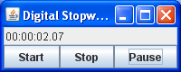
Figure 1 Stopwatch with a Pause Button

Exercise 2 Sketch Application with a Delete Button

- Go to the website for the module and download the code for the ‘Sketch’ application described in the lecture. Check that you can compile and run this code.

- Add a ‘Delete’ button to the application, as in Figure 2. The effect of pressing the delete button should be to delete the last point in the sketch (the one indicated by the red blob) and then to repaint the sketch.

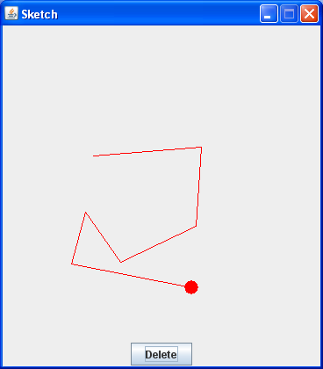
Figure 2 Sketch Application with Delete Button

Exercise 3 Sketch Application with a Mouse Motion Listener

Take the code from Exercise 2 and modify it so that there are two text fields at the bottom of the user interface which indicate the position of the cursor, as shown in Figure 3. The X position of the cursor is the vertical distance, in pixels, between the cursor and the top of the sketch. The Y position is the distance, in pixels, between the cursor and the left hand side of the sketch. The fields should be updated every time the cursor is moved.

I would suggest that you put the two text fields, along with the delete button, into a JPanel (in the same way as you did for the buttons in the stop watch application).

You will also need to make the Sketch class implement the MouseMotionListener interface. This interface defines two methods

- mouseMoved(MouseEvent e)
- mouseDragged(MouseEvent e)

the mouseMoved method is called whenever the mouse is moved. You can obtain the coordinates of the point to which it was moved by calling e.getX() and e.getY(), where e is the MouseEvent argument passed to the method.

The mouseDragged method must be implemented, but its implementation does not need to do anything.

You also need to add call sketchPanel.addMouseMotionListener in order to make the sketchPanel listen to movements of the mouse.

You can find documentation for all the classes and interfaces mentioned here by visiting http://docs.oracle.com/javase/7/docs/api/

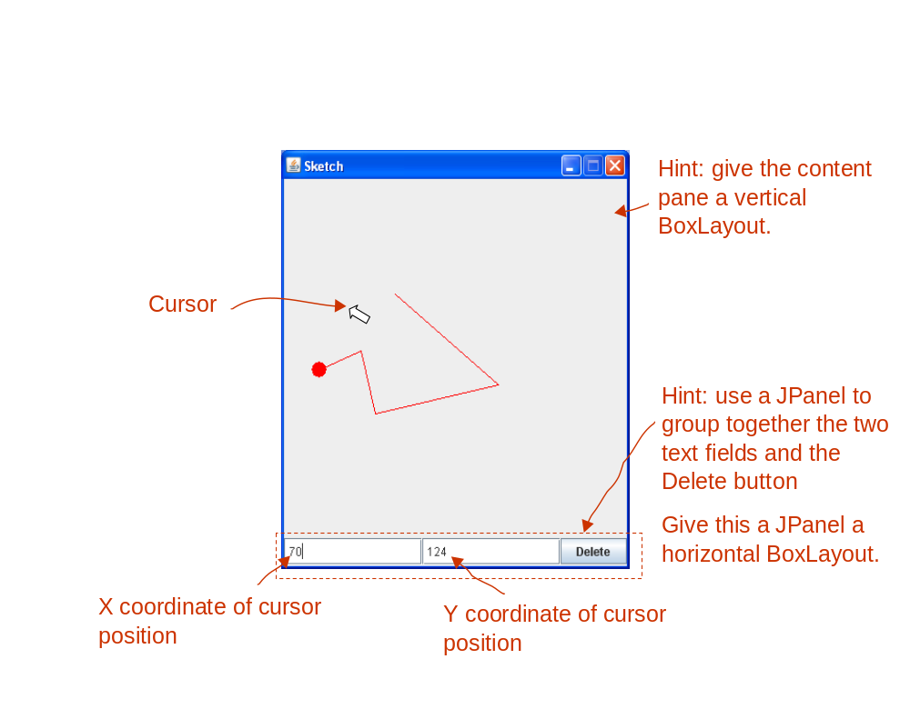
Figure 3 Sketch Application with a Mouse Motion Listener

Exercise 4 Adding an Easy Button

Well done! You’ve worked hard on this. The only thing that our Sketch application needs now is a stress-busting ‘Easy’ button. The Easy button generates a dialog box that says ‘That was easy!’ as shown in Figure 4.

You can create this dialog using the static method JOptionPane.showMessageDialog. You can look this method up at http://docs.oracle.com/javase/7/docs/api/

N.B. There is actually a point to this seemingly whimsical exercise. It teaches you how to create dialog boxes, and it also illustrates the difference between modal and modeless dialogs. The dialog that you create here should be modal, in the sense that once it is displayed you cannot interact with the main window of the application until you have dismissed the dialog.
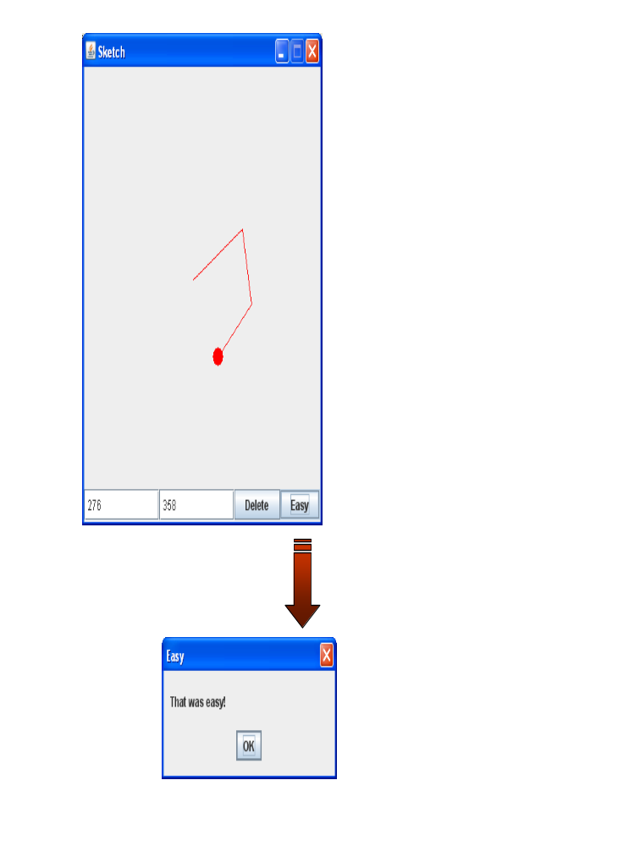
Figure 4 The Easy Button

